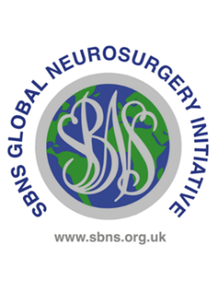

UK and Ireland Neurosurgical Trainees Award

Training Programme Director Form

Dear TPD,
Your trainee is applying to the SBNS Global Neurological Surgery Committee for a travel grant to support a period of study in a low or low middle income country. We are grateful to you for completing this form.
Trainee’s name | Click or tap here to enter text.
ST training year at time of travel | Click or tap here to enter text.

Please confirm all the statements below
☐ | I confirm that this trainee is a run through trainee with a National Training Number
☐ | I confirm that this trainee achieved an outcome 1 at their most recent ARCP
☐ | I confirm that this trainee is not currently under investigation by the GMC or hospital trust
☐ | I confirm that this trainee has been granted leave by the deanery (usually but not necessarily as an OOPE) to undertake this time out of programme
☐ | I confirm that I believe it will be beneficial to this trainee to undertake time out of programme and I support this application

Any additional information?
Click or tap here to enter text.

Your name | Date | Signature
Click or tap here to enter text. | Click or tap to enter a date. | 

