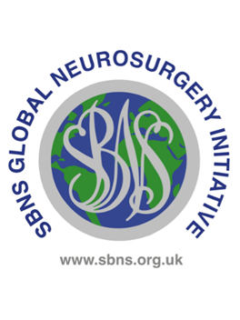

**The Alan and Diana Karter Fund Award**

**UK and Ireland Neurosurgical Trainees Award**

**Selection Criteria**

|  |  |  |
| --- | --- | --- |
| **Criteria** | **Essential** | **Desirable** |
| SBNS membership | The applicant must be a member of the SBNS and have been continuously for at least 2 years |  |
| Stage of training | Run through trainee in UK or Ireland with a National Training Number and at least in phase 2 (ST3 or above) | Early phase 2 trainee ST3 – ST5  Later stage trainees may be considered |
| Satisfactory progression | Outcome 1 at the most recent ARCP | Logbook showing broad exposure, high levels of activity and a high indicative to assisted ratio |
| Country of residence trainer support | Support from the deanery and TPD | Strongly supportive reference from an independent trainer |
| Country of application trainer support | Support from the training authority or regional centre |  |
| Destination | On the world bank LIC or LMIC country list  Likely to provide high quality and high volume surgical training of use to the surgical trainee  Country considered safe by UK government <https://www.gov.uk/foreign-travel-advice> | English speaking or applicant provides evidence of fluency in the local language |
| Reasons for going |  | Compelling reasons for travel especially focussed on own training needs.  Providing medical aid is not normally considered to be a good reason. |